**Introduction**

Many factors affect the plant’s growth, such as light, water, carbon dioxide, temperature, moisture, soil salinity, pH, nutrients, pests, diseases, and so on. It’s important to learn the crop’s living environment to maximize plant growth.

**Items To Monitor**

**Ambient Temperature and Humidity sensing (DHT22)**

Extremely low or high temperatures stunt growth or cause foliage damage, or leaf drop. Relative humidity levels affect when and how plants open the stomata on the undersides of their leaves. That affects the plant’s breath.

**Soil moisture and temperature (** FC-28 soil**)**

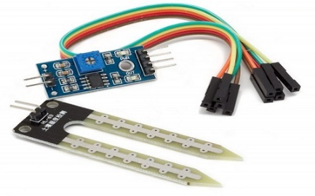

* AM2315 Temperature - Humidity Sensor

<https://www.amazon.com/AM2315-Digital-Signal-Temperature-Humidity/dp/B085X1QK4Z>

# --DS18B20

Prototyping sensor

The soil temperature and moisture are key measure factors indicating soil temperature and water content. Soil temperature influences aeration, soil moisture content, and the availability of plant nutrients. And water content mainly indicates the need for irrigation.

**Ambient Light(**[**https://learn.sparkfun.com/tutorials/temt6000-ambient-light-sensor-hookup-guide/all**](https://learn.sparkfun.com/tutorials/temt6000-ambient-light-sensor-hookup-guide/all)**) TEMT6000 Ambient Light Sensor Hookup Guide**

The light sensor detects illuminance applied in agricultural planting. Many plants will do just fine with a wide variety of light levels while some plants require not too much or too little light. (For photosynthesis)

**Soil Nutrient Level\***

<https://how2electronics.com/measure-soil-nutrient-using-arduino-soil-npk-sensor/>

<https://www.amazon.com/Taidacent-Detector-Agricultural-Phosphorus-Potassium/dp/B08MXXSP59>

RS485 BOARD - <https://www.robotistan.com/ttl-rs485-serial-converter-board-max485>

* (search for protype of this)

Nutrient dosing to the plants can also be automated. You can achieve higher yields and better quality crops by providing plants with what they need when they need it.

When feeding plants with nutrients, the IoT system can accurately and precisely dose nutrient recipes allowing you to automate your entire fertilizer  strategy from seedling to harvest.

**PH Control* --** [**https://www.seeedstudio.com/Grove-PH-Sensor-Kit-E-201C-Blue-p-4577.html**](https://www.seeedstudio.com/Grove-PH-Sensor-Kit-E-201C-Blue-p-4577.html)

**PH Sensor Kit (E-201C-Blue ) – search for industrial**

By using a PH sensor you can measure the soil PH. You can then set the target pH in your recipe up or down to hit your target pH and adjust for fluctuation in supply water.

**Electrical Conductivity**

**Hardware Options**

1. **Lora**

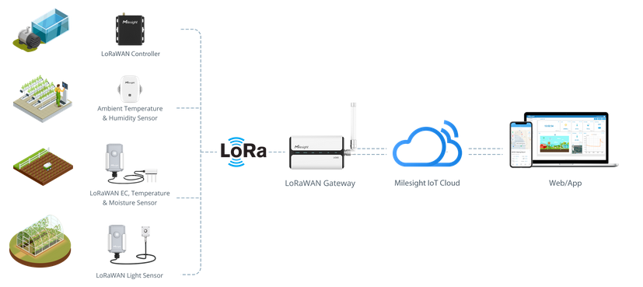

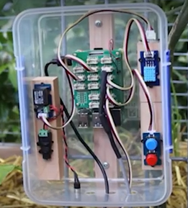

The gateway collects data from sensors which are in the field then sends them to the Angaza Elimu IoT cloud platform. Users can remotely monitor crop’s environmental conditions on the Angaza Elimu Cloud platform anytime anywhere.

Users can set up the threshold and receive an alert once the threshold is reached, then using the Controller (relay controller) to take action.

In addition, users can also set up combined triggers to automatically take actions. For example, an event can be scheduled to automatically turn on the pump for 20 minutes while the soil moisture level is less than 6%.

**Components**

* Ambient temperature and humidity sensor
* Soil temperature sensor
* Soil moisture sensor
* Ambient light sensor
* EC sensor
* Solar panel
* Charging circuit
* Relay controller
* Water pump
* UV light (for demonstrating light control in a indoor greenhouse)
* LoRa connectivity
* Lora gateway
* An IoT cloud platform

**How it works**

Microcontroller: Raspberry Pi Pico W

Programming Language: Python

Communication Protocol: LoRa

Data protocol: MQTT

Enclosure: An enclosure will be used to hold the sensors and microcontroller

Power options: Battery powered, direct connection for gateway, solar power